Blood Donor Interest Form
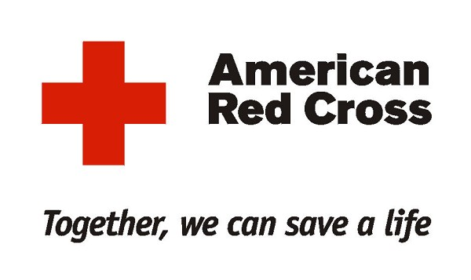
Blood Drive: Monday, February 27th (DGEF)
Is it safe to give blood?
Donating blood is a safe process. Each donor’s blood is collected through a new, sterile needle that is used once and then discarded. Although most people feel fine after donating blood, a small number of people may feel lightheaded or dizzy, have an upset stomach or experience a bruise or pain where the needle was inserted.
Blood Donors Must:
- Be healthy
- Be at least 17 years old, or 16 years old with parental consent (separate form)
- Weigh at least 110 lbs.
Name: _______________________________________ Grade: ______
D-Block Room Number: _____ 1st-Block Preference____ 2nd Block Preference: ______
You will receive an appointment card in your D-Block class on Monday, February 27th.
- - - - - - - - - - - - - - - - - - - - - - - - - - - - - - - - - - - - - - - - - - - - - - - - - - - - - - - - - - - - - - - - - - -
Blood Donor Interest Form
Blood Drive: Monday, February 27th (DGEF)
Is it safe to give blood?
Donating blood is a safe process. Each donor’s blood is collected through a new, sterile needle that is used once and then discarded. Although most people feel fine after donating blood, a small number of people may feel lightheaded or dizzy, have an upset stomach or experience a bruise or pain where the needle was inserted.
Blood Donors Must:
- Be healthy
- Be at least 17 years old, or 16 years old with parental consent (separate form)
- Weigh at least 110 lbs.
Name: _____________________________________ Grade: ______
D-Block Room Number:______ 1st Block Preference: ________ 2nd Block Preference ______
You will receive an appointment card in your D-Block class on Monday, February 27th.

